19th November 2018

**Italian Veteran Tarquini Champion of FIA WTCR in Macao**

The inaugural season of the FIA World Touring Car Cup – WTCR came to a dramatic climax at Macao at the weekend. The Championship, which has the Japanese premium tyre manufacturer YOKOHAMA as exclusive tyre supplier proved the excitement of the race series, due to the high-level competition displayed by teams and drivers involved during all the race weekends.

The Italian veteran Gabriele Tarquini on a Hyundai powered i30 N TCR, BRC team car, made good his 39 points lead going to the last races in Macao. Although the gap between him and the 4 times WTCC World Champion and veteran Yvan Muller - also on a Hyundai 130 N TCR - was significant, the tricky street circuit in Macao, enabled him to only just stay in front at the end of a nail-biting final race.

The French driver Muller, who had cause to celebrate later on with his own YMR team winning the team title, performed extremely well throughout the three races in the former Portuguese colony and was within a real chance of causing an incredible comeback. Muller managed to “bite” away the advantage in the three races, to bring it down to a mere 3 points – which ultimately decided the season’s Champion.

At 56, the veteran Tarquini’s season started off really well with a season opening victory in Morocco where he claimed his intentions for the title and continued with strong performances in Hungary, Portugal, Slovakia and Japan. His solid results made him a front runner towards an eventual World Championship - his second in his career in touring cars, following the WTCC title in 2009. In actual fact, Tarquini had contemplated retirement after his World Championship, as he claimed perhaps there was little motivation left for him to carry on. However he continued and yesterday was according to comments made to the media, “a long and tough season, but the best so far in his career”. Tarquini was delighted with his triumph and thanked Hyundai, his team, team-mate Michelisz, mechanics and engineers and all those who helped him. He was also honourable and had a kind word for his biggest rival this year, Yvan Muller, congratulating him on such a good performance all season and being his “toughest opponent throughout the series”.

For his part, the Argentine Esteban Guerreri on a Honda Civic TCR, managed a meritorious third overall in the series, just ahead of Norbert Michelisz, who had to settle for 4th place at the end of the season.

A spokesman for YOKOHAMA Europe expressed satisfaction with the season and congratulated the winners of the inaugural season and thanked the YOKOHAMA Motorsport Support team for their efforts to ensure the high performance required and expected by all the drivers and racing teams. “It was an exciting Championship – congratulations to Gabriele Tarquini, Yvan Muller and Esteban Guerreri for their splendid season. We are happy to have played our part with our YOKOHAMA tyres and technical expertise to ensure maximum high performance and safety” he concluded.

**FINAL FIA WTCR DRIVER STANDINGS* (subject to confirmation from FIA)**

**Gabriele Tarquini 306 pts**

**Yvan Muller 303 pts**

**Esteban Guerreri 267 pts**

**Norbert Michelisz 246 pts**

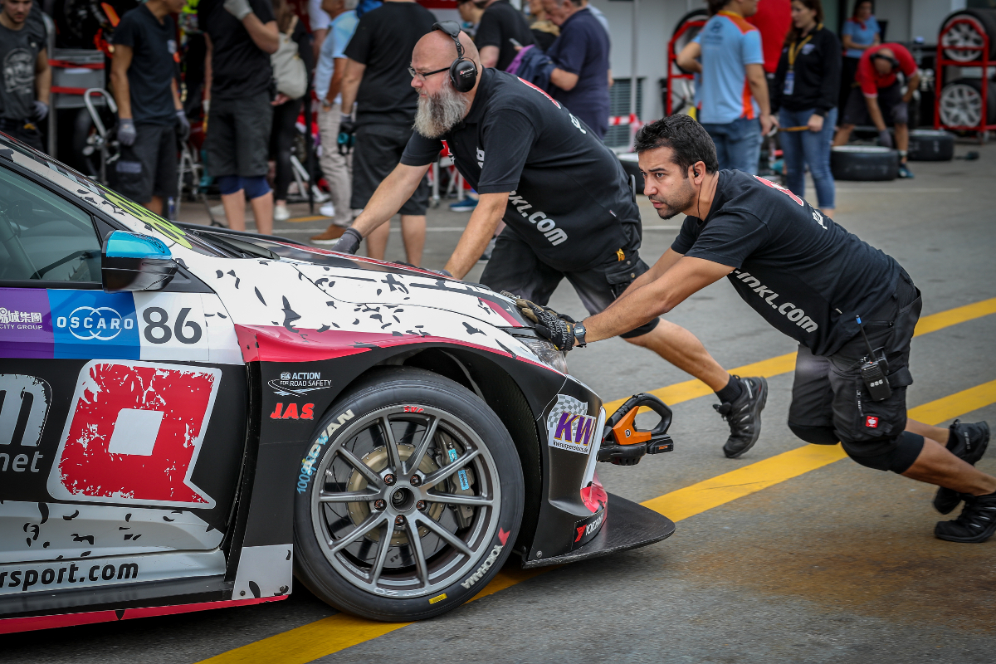

*Teams get ready Photo Alexandre Gillaumot DPPI*

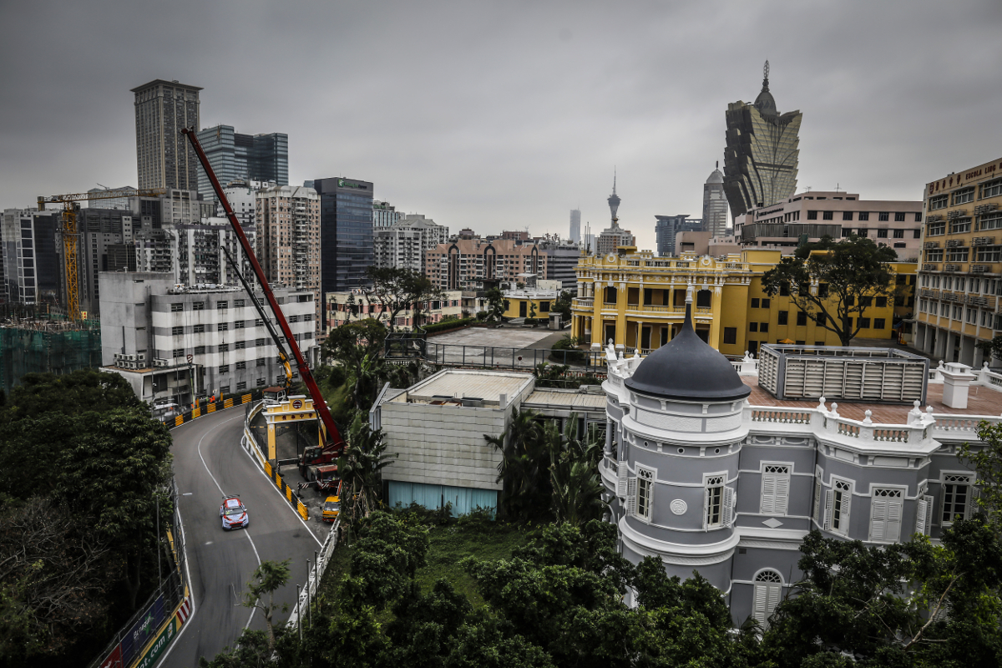

*Gabriele Tarquini at Circuito da Guia Macau Photo Francois Flamand DPPI*

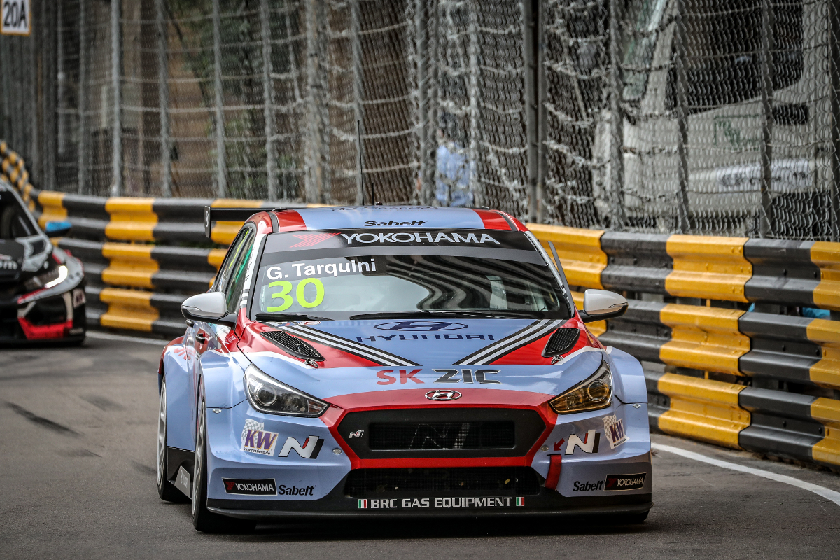

*Tarquini reigns the FIA WTCR Photo Alexandre Gillaumot DPPI*

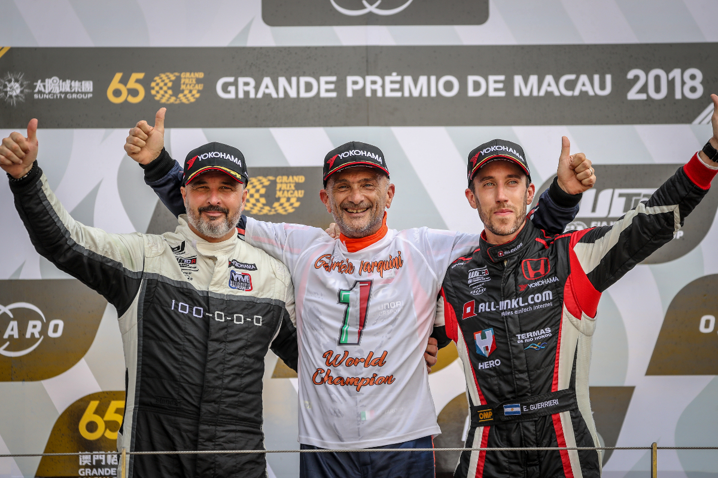

*Left to Right Y Muller G Tarquini and E Guerreri final standings in FIA WTCR Season Photo Alexandre Guillaumot DPPI*